**Web Engineering Exercise 8 – Problem 1**

**s1240234 Yuta Nemoto**

Screenshot: Creating new Product

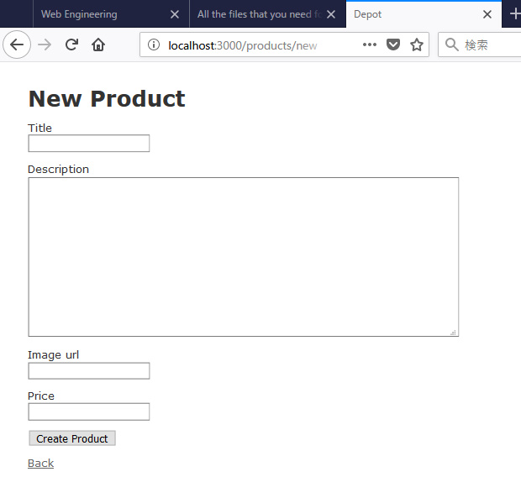

Screenshot: Validation activated and shows error when the particular field is blank.

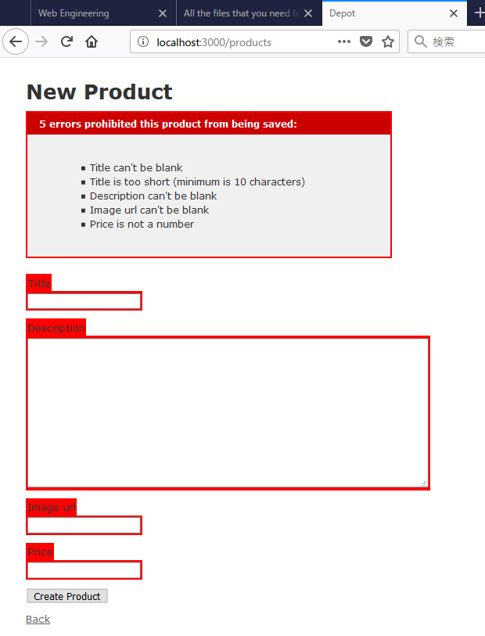

Screenshot: List of Products

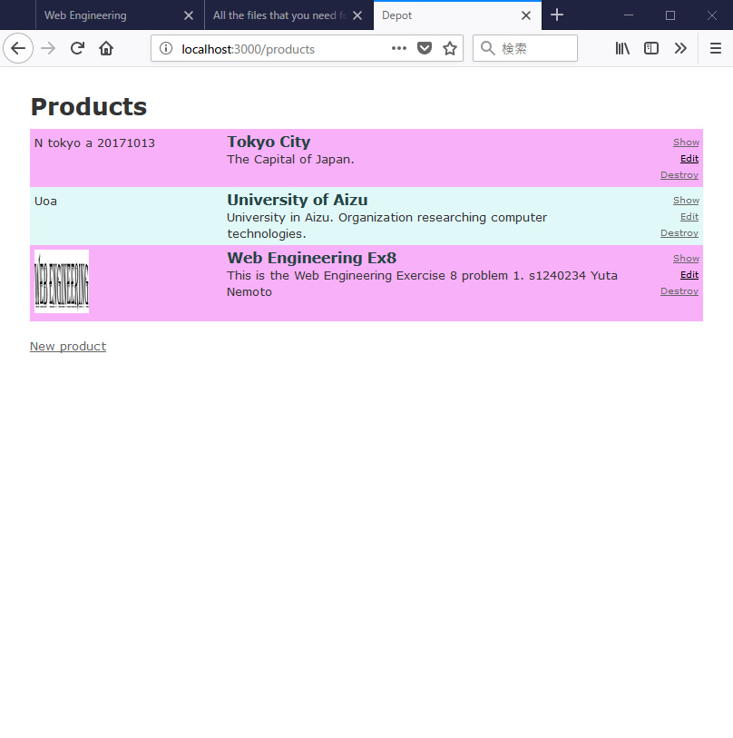

Screenshot: Validation is active in editing page also.

